EXPERIMENT NO. 03--- BPSK Modulation Scheme



Group Number:
Name:
Roll Number:

____________________________________________________

Design and Simulation Laboratory-Communication Systems
Department of Electronics & Electrical Communication Engineering
Indian Institute of Technology Kharagpur
____________________________________________________

TITLE: Design of binary phase shift keying (BPSK) modulation scheme
_________________________________________________________________________________
PROBLEM STATEMENT: Using the PN sequence generated in the previous experiment as data:
- Design and implement a circuit for the working of modulator and demodulator for the binary phase shift keying (BPSK).
- Extract the BPSK modulated data stream, and using MATLAB, demodulate the original data stream (in software domain). Now perturb the BPSK modulated data by adding appropriate noise (additive Gaussian noise) to simulate transmission over an additive Gaussian noise channel, and attempt to demodulate with the same demodulator (take three different noise variance values). Comment on your observation.
_________________________________________________________________________________
KEY COMPONENTS: IC741(Op-Amp), IC74164 (8-bit shift register), ICM4016(Quad Bilateral Switch), Resistors and capacitors, Potentiometer, Digital oscilloscope, Function generator, Breadboard, Connecting wires, and Power supply.
<Add more as necessary>
BRIEF THEORY & BACKGROUND:
The experiment aims to design circuits for the modulation and demodulation of binary data streams by using various digital modulation techniques.

Why Modulation?
< Brief writeup should cover: basic theory of carrier (digital) modulation, different methods of carrier modulation, and specific advantages of such modulation.>

What is Binary Phase-Shift Keying (BPSK):
<Describe the working of a BPSK scheme>
Include a block diagram, and explain the working of the scheme.
.

Advantages/Disadvantages of BPSK modulation scheme and their core usage??
<To-do> In your final writeup, comment on the applications of BPSK and QPSK modulation schemes, and describe the application in a few words

EXPECTED OUTCOMES:

1. [Design and circuit implementation] Design a circuit that modulates and demodulates the previously generated 31-bit PN sequence using the BPSK modulation scheme.
<In this case, both the block diagram and the circuit diagram for the modulator/demodulator are to be designed by the group. Present clearly the block diagram followed by the specific circuit diagram.
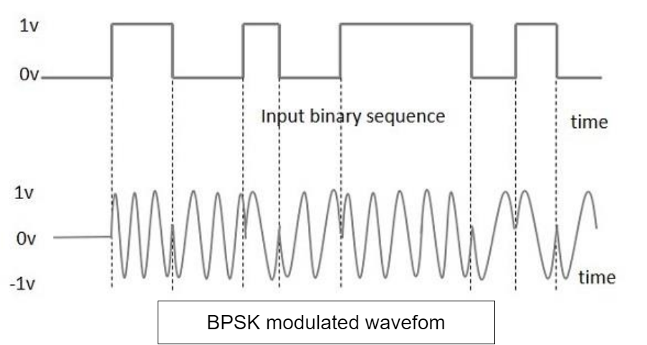

For software parts:
- Export the BPSK data in .csv format from DSO and build a simple detector. Plot the BPSK modulated and the final demodulated data.
- Export the BPSK data in .csv format from DSO and “simulate” the passing of this data through a noisy channel by adding an independent Gaussian random variable (zero-mean and appropriate variance). Now attempt to decode the original data stream in MATLAB. Repeat for at least three different values of noise variances (low, medium and high) and observe the “error” in decoding.
- Construct an average error probability versus noise variance plot. For this plot, run this experiment N=256 times (for each value of noise variance) and plot the average probability of error as a function of the noise variance (as noise variance increases, the signal-to-noise ratio decreases). Comment on your observations.

ACKNOWLEDGEMENTS:
Mention (enumerate) all references including private communication, reference papers, public articles, etc. Look up online resources to understand how references are cited.

REFERENCES:
<Add appropriate refefences>

